Contents

1 Site entry before sign in 2

1.1 After Sign in 2

2 List of Activities 3

3 Add new Activity 3

4 Create new 4

4.1 Create confirmation 4

5 ChangeActivity 5

6 About Us 5

# Site entry before sign in

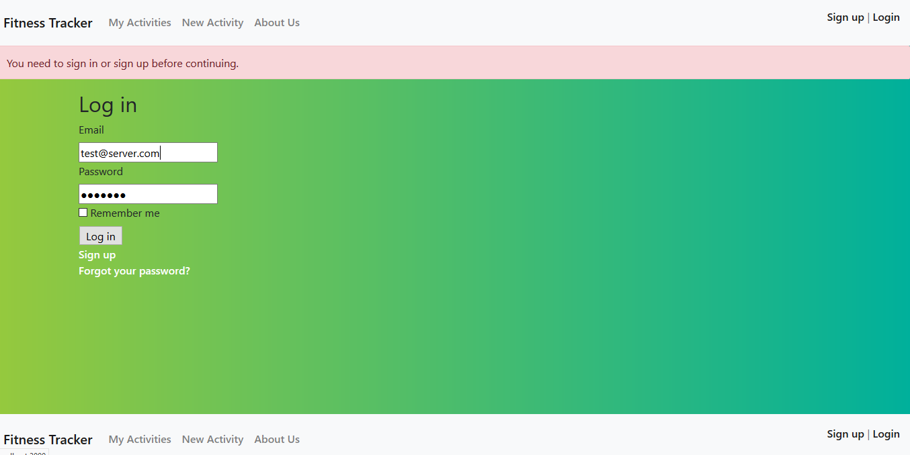

## After Sign in

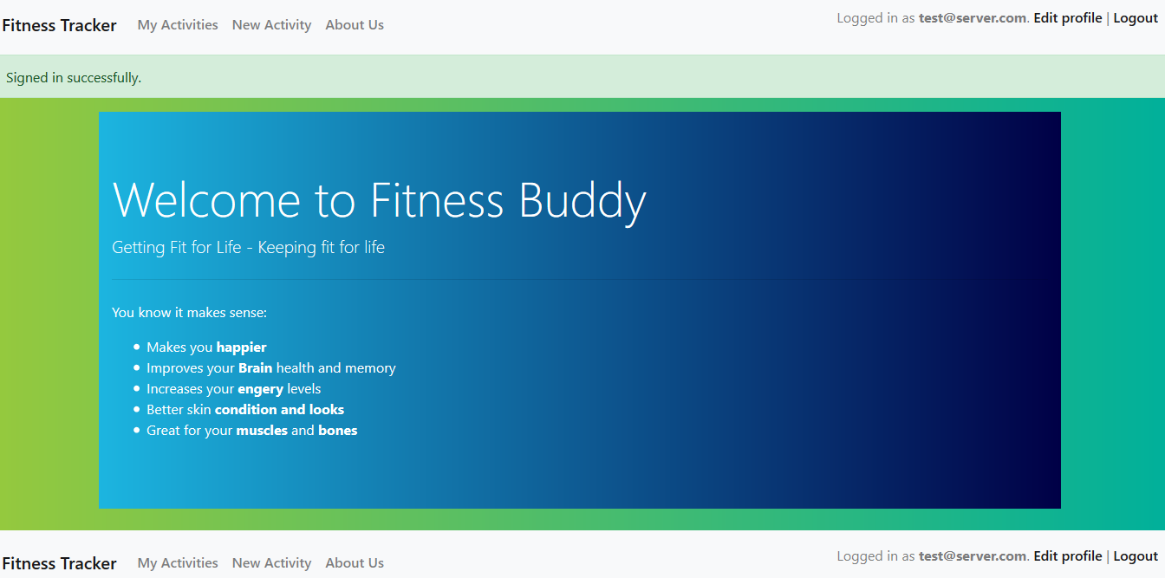

# List of Activities

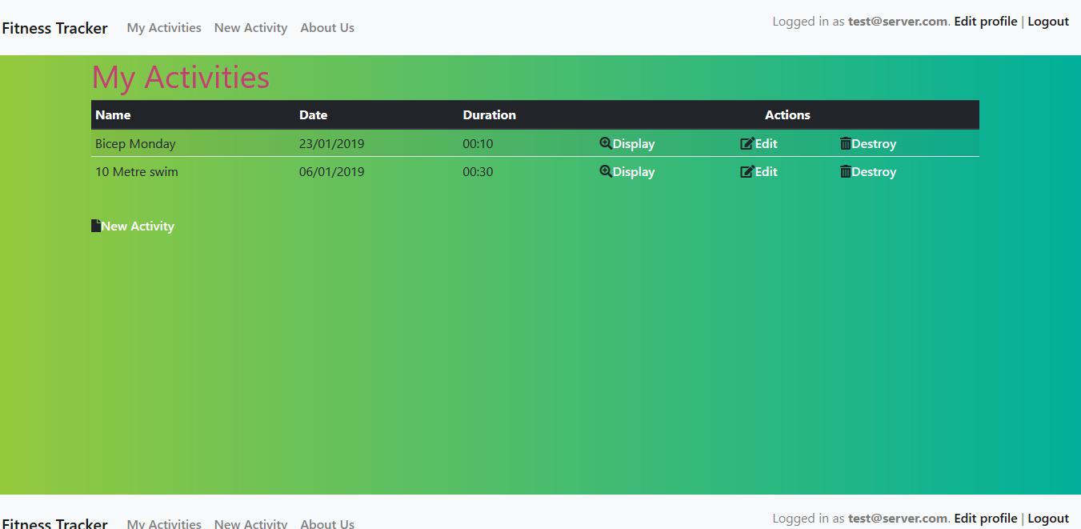

# Add new Activity

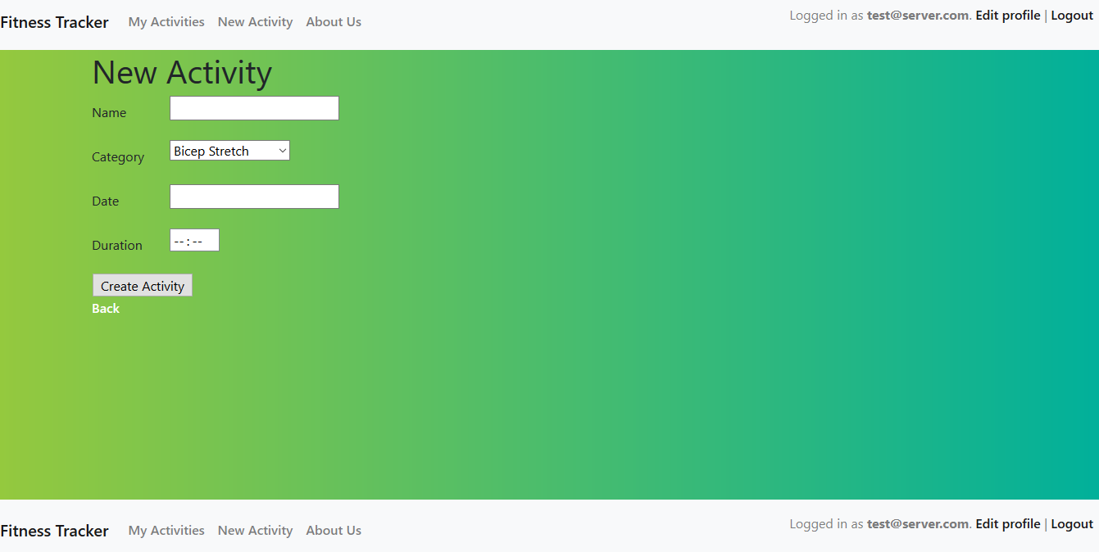

# Create new

Add with Jquery datepicker

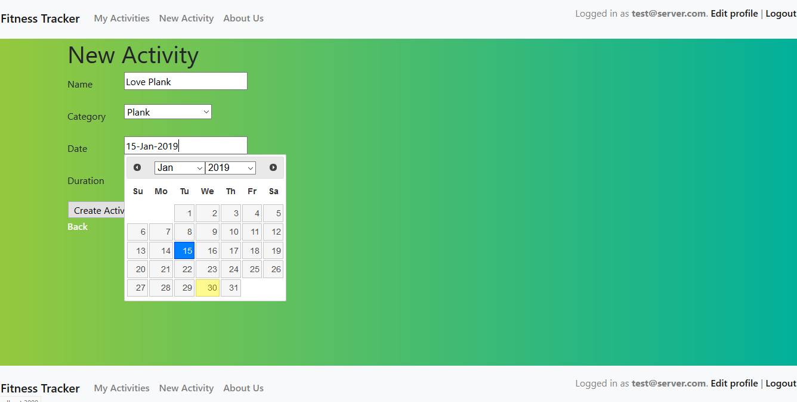

## Create confirmation

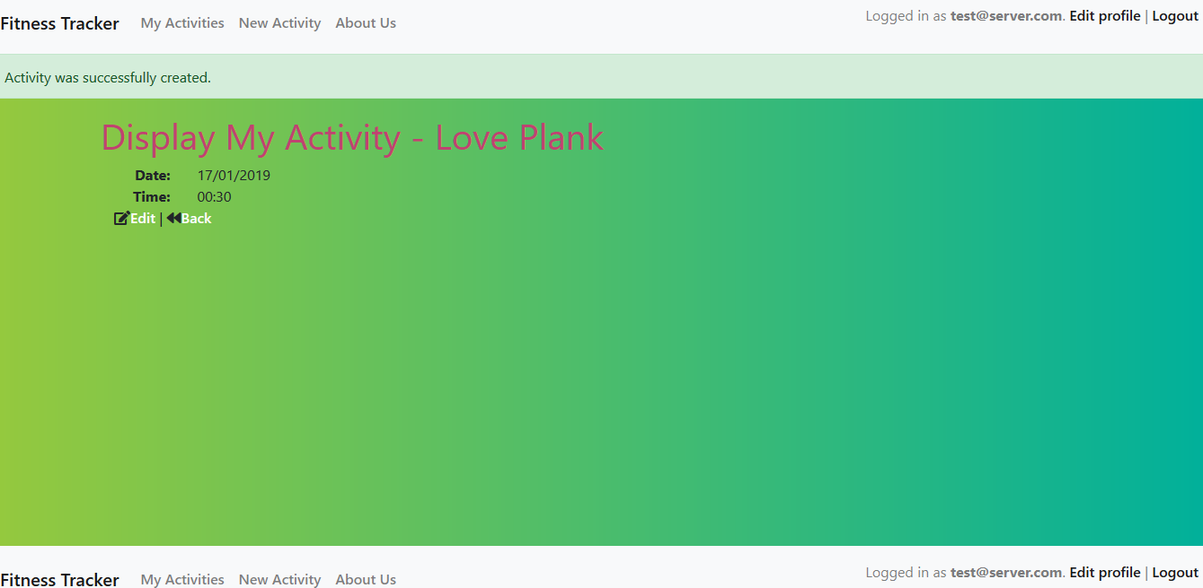

# ChangeActivity

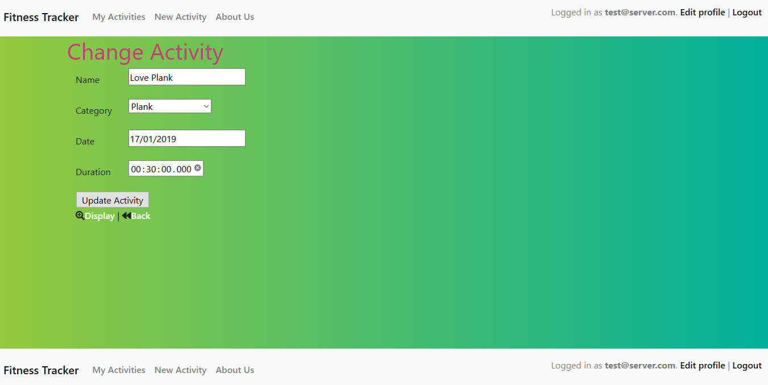

# About Us

